CHALLENGES OF HADOOP 1.X

In hadoop 1.x the name node is a single point of failure.

If the name node fails,the entire system collapses.

There is no backup for the name node.

There can be only one name node for the entire system.

So, the entire load was on a single name node..so if the data is huge processing slows down and the efficiency reduces.

Inorder to overcome all these challenges two new concepts were introduced in hadoop 2.x.

COMPONENTS OF HADOOP 2.X

The components are

1.namenodes

2.datanode

3.secondary name node

4.HDFS Federation

5.HDFS high availability

NAME NODE

It consists of the metadata of files and the hadoop file system tree.

The name node distributes data among the different data nodes.

It contains of details of which block is stored in which data node.

There can be more than one name node in hadoop 2.x.

A single name node may be connected to various data nodes.

Two or more name nodes can be connected to two or more data nodes.

They act like the master node.

It does not store any data.

If the all name nodes fail the entire cluster fails.

SECONDARY NAMENODE

It performs checkpoints on the metadata in namenode.

It does not act as a name node even if name node fails.

It helps the name nodes.

DATANODE

It stores the actual data of the hadoop filesystem.

It notifies the name nodes of the data it holds

It signals name nodes when it starts processing its data.

The signals are sent often to indicate it is active.

Those signals are known as heartbeat.

They act like the slaves.

It performs the works assigned to it from the name node.

There can be any number of data nodes.

HDFS FEDERATION

In HDFS Federation there can be multiple name nodes.

The name nodes contain subdirectories which store the metadata and the block mapping of files in particular sub directories.

The checkpointing is done by the secondary name node.

The sub directories of the name nodes are called as namespace volumes.

The files in a namespace volume is called a block pool.

The root directoy consists of two sub directories, /usr and /share

Here, even if a name node fails, the system does not fail as there are other name nodes.

The mapping can be handled by a name node while the other name node stores the meta data.

The data nodes can contain data blocks from different name nodes.

Let us consider name node 1 consists of namespace volume 1 and name node 2 consists of namespace volume 2.

The name node 1 is mapped to data node 1 and data node 2.

The name node 2 is mapped to data node 2 and data node 3.

Hence, the data node 2 contain blocks from both the name nodes 1 and 2.

Hence the namespace volumes are divided among the name nodes but not among the data nodes.

A drawback is that name node 1 cannot access data node 3 and name node 2 cannot access data node 1.

So if name node 1 fails the data in the data node 1 will be lost.

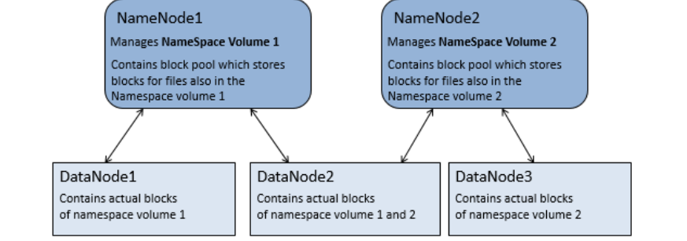

Hdfs Federation is used in case of increasing the cluster size in HDFS if a single name node is not able to hold the entire mapping of HDFS,so that they are distributed among multiple name nodes.

HDFS Availability

In the HDFS availability there a two name nodes, one is the active name node and the other is a standby name node.

The standby name node takes the control if the active name node fails.

Here, the name node is capable of storing the entire mapping of the HDFS.

All the data nodes are connected to both the active and the standby name nodes.

Here the check pointing is done by the standby name node.

The standby name node also checks the active name node periodically.

Data nodes send the blocked reports to both the name nodes because of block mappings.

The active name node must use its shared storage to share the edit logs.

The edit log is read by the standby name node when it takes the responsibility.

The data nodes notify the name nodes of the blocks it contains.

